

Ministry of Skills Development, Employment and Labour Relations

**Name of**

**Project** TuitionClass Tute Registration System

|  |  |  |  |  |  |  |  |  |  |  |  |  |  |  |  |  |  |  |  |  |  |  |
| --- | --- | --- | --- | --- | --- | --- | --- | --- | --- | --- | --- | --- | --- | --- | --- | --- | --- | --- | --- | --- | --- | --- |
| M | . | K | . | P | . | P | . | G | A | M | Y | A | M | A | N | I |  |  |  |  |  |  |
|  |  |  |  |  |  |  |  |  |  |  |  |  |  |  |  |  |  |  |  |  |  |  |

**Student Name**

|  |  |  |  |  |  |  |  |  |  |  |  |  |  |  |  |  |
| --- | --- | --- | --- | --- | --- | --- | --- | --- | --- | --- | --- | --- | --- | --- | --- | --- |
| J | L | / | 2 | 2 | / | I | C | T | 5 | / | 1 | / | 0 | 0 | 0 | 7 |

**MIS**

**No**

|  |  |  |  |  |  |  |  |  |  |  |  |
| --- | --- | --- | --- | --- | --- | --- | --- | --- | --- | --- | --- |
| 2 | 0 | 0 | 1 | 8 | 2 | 6 | 0 | 2 | 4 | 6 | 6 |

**Student**

**NIC**

|  |  |  |  |  |  |  |  |  |  |
| --- | --- | --- | --- | --- | --- | --- | --- | --- | --- |
| 2 | 0 | 2 | 2 | / | 0 | 8 | / | 0 | 4 |

**Submission**

**Date**

**Center**

**Name** NVTI Baddegama

**Batch** 2022 First Batch ICT V

**Supervisor**

**Name** Mr. Nishantha Gamage

**Supervisor**

**Comments**

**Signature of**

**Supervisor**

|  |  |  |  |  |  |  |
| --- | --- | --- | --- | --- | --- | --- |
| **Official Use Only** | *Approved* |  |  | *Revised* | *Reject/Resubmit* |  |

1. **Problem Statement**

* **What is the problem?**
* Nowadays the educational system has been a very wide sector in the world. Rather than the schools, the tuition classes play a major role in the education sector. In our country, tuition industry is way popular than the school system. So, there are so many full time tuition class teachers occupying in that sector.
* One of the major problems they face during the tuition class management is not having a proper method to handle their tutes properly. The teachers often forget how many tutes they have for the each unit, what tutes did they gave to the students , what tutes did the students finished ,what tutes belong to a certain unit etc**.**
* **Who has the problem?**
* Basically the teachers suffer the most because of this problem.

1. **Domain/ Problem area**

* Because the teachers couldn’t easily arrange their tute works, both the teachers and the students are having negative impacts. Due to teachers is not that efficient, the students may tend to unattend to their classes anymore. It will cause a negative effect on the relevant tuition class area.

1. **Proposed Solution/ Scope**

* The new system that I hope to develop will be able to meet the needs of the teachers to manage their precious time. The teachers can easily recognize the relevant tutes with the relevant units and also they can make simple changes of the tutes database as they wish. It can be done by the teacher himself and no need to have an extra person to handle the database.

1. **Project Assumptions and Constraints**

* Project Assumptions
* All the resources are sufficient and are in a good condition.
* I might have the required skills to build the system.
* Project Constraints
* The project is an individual project.
* There are possible power cuts.
* Must complete the project within one month.
* Have to work with the available resources.

1. **Methodologies going to be used.**

* I hope to use waterfall methodology.

1. **Weekly Basis Project Plan**

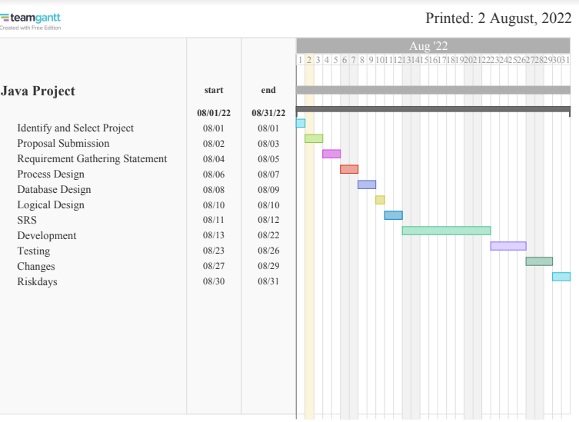

1. **Supervisor**

* Mr Nishantha Gamage

1. **Approval**